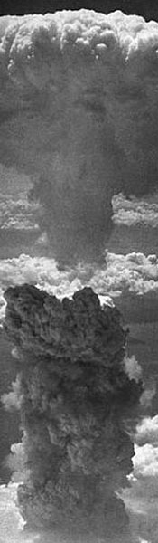
With nearly 1,100 American World War Two veterans dying each day, a generation that saved the world from tyranny is slowly disappearing. But the controversy that ended the war, the dropping of two atomic bombs on Japan still stirs emotions and critics today. These two bombs, which killed an estimated 100,000+ Japanese citizens, ushered in a new age of warfare to the world: the nuclear age. An age that created a Cold War that lasted nearly forty-five years between the United States and the Soviet Union, which brought the world to the brink of a nuclear holocaust. But was the dropping of these bombs on Japan necessary? Could the end of World War II have gone any other way? Did the United States use these bombs to defeat Japan or to send fear in to the heart of Joseph Stalin, the leader of the Soviet Union? These are just some of the ideas we will be contemplating within this lesson on the decision to drop the atomic bomb. Carefully read through each section below and fully explore each web site (spend time looking at the links within the links on each site) to gather information to response to blog questions that you will be assigned to answer. In addition to answering your blog question you will also be required to respond to at least five blogs posted by one of your classmates. Your answer to your question must be at least 250 words long and your responses to your classmates must be at least 50 words long.

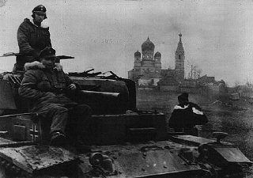
With the defeat of Germany in May of the 1945 the Allies could now switch their attention fully to Japan. With the Yalta Conference in early 1945, the Allies had already set the stage for the last part of the war. Look up the above links on Germany (check side links for picture and image galleries) and the Yalta Conference as well as the Peace Terms to brush up on the reasons and actions that lead to Germany’s surrender ending the war in Europe and what the Allies planned to do next. Produce an article for your newsletter on these items.

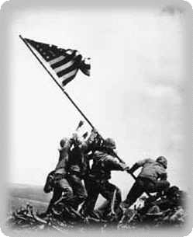
The island hopping campaign with Japan had become very costly and tedious throughout 1943 and 1944. Two key battles fought in 1945 will play an important part in how the end of the war with Japan would go. Please review the following links on the Battles of Iwo Jima and Okinawa Iwo (check picture and image galleries), Battle of Okinawa (check picture and image galleries) and write a column on the importance that these battles played in the war against Japan and the planning for the end of the war.

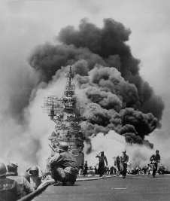
It was during this portion of the Pacific War that the United States was introduced to Kamikazes (pay particular attention to American and, Japanese stories from this site). Add a column to your newsletter describing the Kamikazes and the importance they played in United States policy making for the remainder of the war and the impact they had on Japan itself.
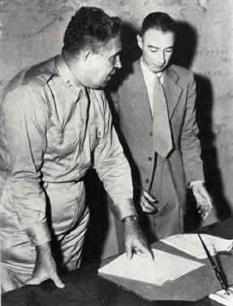
With the amount of American deaths mounting and the death of President Roosevelt in April 1945, newly anointed President Truman was faced with a major dilemma on how to end the war. It was during this time that he was introduced to the Manhattan Project which described America’s newest potential weapon the Atomic Bomb. Look carefully at these sites and the Interactive History of the Manhattan Project on the people and the process it took for America to become the world’s first nuclear nation. Write up a story on this to add to your newsletter.

Once this new weapon was created it needed to be tested. Eyewitness History, the actual Trinity Test and Video of a Nuclear Test should be used to prepare your next newsletter item. Pretend you are one of the scientists working on the Manhattan Project and write up an eyewitness account to America’s first nuclear test. What type of feeling and expressions took place? Was it the right thing to do?
What was it like? Use your imagination.

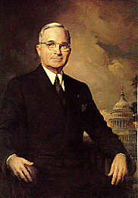
With the creation of the bomb President Truman now needed to decide if dropping the bomb was the correct thing to do. Your assignment is to put yourself in President Truman’s shoes and write a persuasive editorial to your newsletter describing why the bombs should or should not be dropped. You must pick one side or the other, you cannot stray the fence. Use the following sites to help you in your decision making process. Why?, The decision! (this comes from Truman’s Library and does contain nearly 600 pages of material/do some heavy searching), Drop Bomb, Impact of Bomb, Potsdam Conference, Recent Views, Essays and Critics.

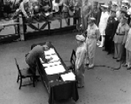
On August 6, 1945 and August 9, 1945 the United States dropped two Atomic Bombs, Fat Man and Little Boy (from two B-29 bombers Enola Gay and Box Car) on the Japanese cities of Hiroshima and Nagasaki, killing an estimated 100,000+ Japanese citizens. Even though there is still controversial today into whether the dropping of the bombs actually persuaded the Japanese to end the war; Japan surrendered on Aug 14, 1945 with the official surrender ceremonies taking place aboard the U.S.S. Missouri on September 2nd. Finish your newsletter by using the above linked information as well as the Japanese Guide to the dropping of the bombs to formulate the importance of America’s dropping of the two atomic bombs on Japan, the war, and what impact they had/have on the world today.

Blog Questions:
- Was the dropping of these bombs on Japan necessary?
- Could the end of World War II have gone any other way?
- Did the United States use these bombs to defeat Japan or to send fear in to the heart of Joseph Stalin, the leader of the Soviet Union?
- After spending so much money (200 plus million) producing an atomic bomb that it was necessary to use it in order to justify all the money spent to build it?
- Did dropping the atomic bomb prevent an American invasion of Japan?
- If Truman had already concluded that Japan was ready to surrender, why did he decide to drop the atomic bomb on Japan?
- Did the United States drop the atomic bomb to defeat Japan or to intimidate the rest of the world?
- Why did Truman use the atomic bomb on Japan when he wrote in his diary that “Japan would surrender as soon as the Soviet Union entered the war?”
- Why did Truman tell the American people that it was necessary to drop the atomic bomb on Japan to end the war when many top military leaders such as Eisenhower, Leahy, and Bard told him that it wasn't necessary to drop the bomb?
- Why didn't Truman allow the Japanese to make a conditional surrender?
- Why, if most American historians have concluded that it wasn't necessary to drop the atomic bomb on Japan in order to end the war do so many Americans continue to believe that dropping the bomb ended the war?
- Was the United States “forced” to drop the atomic bomb on Japan like President Truman concluded in 1946?
- Why are so many Americans so uncomfortable with the growing evidence that the United States didn't need to drop the bomb to end the war against Japan?
- If there is evidence to suggest that the United States did not need to drop the atomic bombs on Japan, which there is, does that take away from anything that the United States did and accomplished in World War II?
- After Soviets agree to enter the war against Japan on August 15th, Truman ordered that the atomic bombs be dropped on August 6th and 9th, 1945. Should have Truman waited for the Soviets to enter the war against Japan before he made this decision?
- Was the only other option than dropping the atomic bomb the military invasion of the Japanese mainland, which was estimated to produce a million American casualties, as well as countless Japanese causalities?
- Should have the destructive power of the atomic bombs prevented us from unleashing them against the Japanese?
- It is a known fact that the US did not know the amount of damage the bomb was going to create, or the effects it would have on the people affected by the radiation. Was dropping the atomic bomb on Hiroshima was an inhumane?
- Should have the United States demonstrated the power of the atomic bomb to Japan by bombing it on an unpopulated area, not incinerating two heavily populated Japanese cities?
- Instead of using the atomic bomb should the United States have continued to blockade the country in hopes of cutting off all food and resources to the island, which may have possibly cause them to surrender?
- It is a prove fact that the Japanese were not very nice to American prisoners of war does the Japanese treat of American soldiers justify dropping the atomic bomb?
- The Japanese Emperor had agreed to surrender as long as the United States allowed the Emperor to continue to rule in Japan. After the bombing of Japan the Emperor was allowed to stay in power anyway so was dropping the atomic bomb necessary?
- Did dropping the atomic bomb on Japan create a more peaceful world or a more dangerous one?
- Would have the United States of American have been better off if the Manhattan Project never existed?
- By today’s standards, the atomic bombs dropped on Japan are not really that powerful. Do you trust the ability of humans to continue to control such dangerous weapons?
- Would have the Cold War that existed between the United States and the Soviet Union, that lasted for over forty-five year, have taken place if the United States decided not to drop these atomic bombs on Japan?
- Recently, President Obama got some major countries in the world to agree to destroy their nuclear weapons. Is this a good or bad idea in our modern world?
- Was it necessary for the United States to drop a second atomic bomb on Nagasaki?
- One thing that motivated the United States to build an atomic bomb was the fact that German scientist had been attempting to create an atomic bomb for years. Does this fact justify America’s effort to create an atomic bomb?
- A letter written to President Roosevelt by Albert Einstein was a major factor in the United State’s decision to start the Manhattan Project. Einstein would later say that his biggest regret in life was writing this letter to President Roosevelt. Is Albert Einstein to blame for the death of over 100,000 Japanese citizens?

