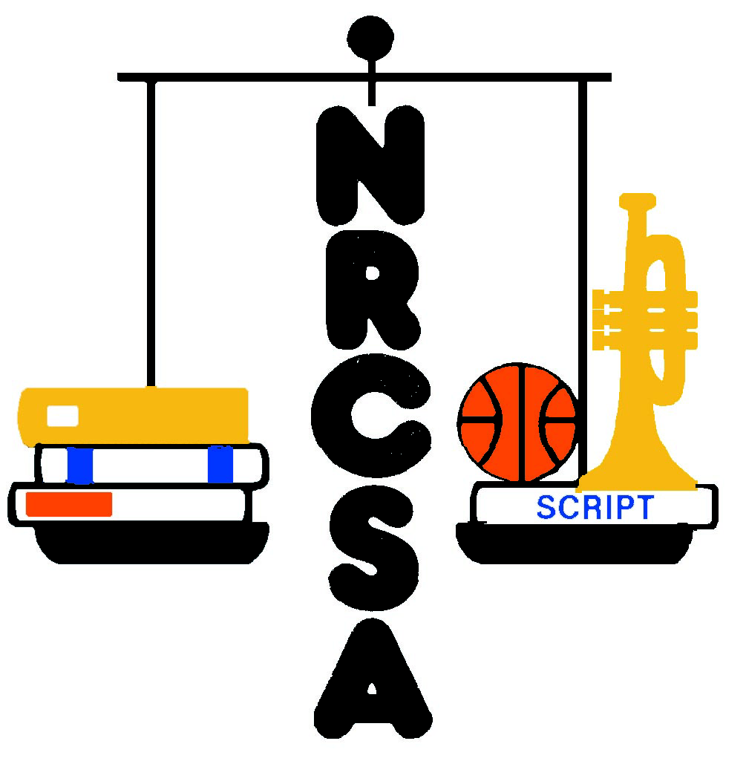

NEBRASKA RURAL COMMUNITY SCHOOLS ASSOCIATION

JAN. 13, 2020

STANTON COMBINED PROFILE WORKSHEET

- List the greatest strengths or positive qualities of your school district.

BOARD:
- Small enough to care; big enough for opportunity.
- Offer pre-K-12 education
- Small town living but still close enough to Norfolk, Omaha, Lincoln, Sioux City.
- Great retention of tenured faculty/staff.
- Close to WSC teachers’ program .
- Transportation. MS/HS great shape.
- Small class size
- MTSS process in elementary
- Community involvement
- 1:1 computer technology
- Really good staff
- High school building in good condition.
- Financially sound
- Up-to-date technology
- Cooperative people
- Excellent school system

FACULTY/STAFF COMMITTEE:
- Good community support. Very welcoming community.
- Excellent teachers and staff.
- Hard-working kids.
- Good programs: mentor programs for new teachers; Teammates program for youth.
- 1:1 initiative in Gr. 7-12. Windows 10 laptops.
FACULTY/STAFF (Continued)
- Flexibility and ability to adapt to change.
- Lots of activity opportunities – fine arts, sports, etc. Activities treated equally.
- Staff works together and gets along because small number of students must do everything.
- Good process for developing curriculum.
- Always seeking improvement.
- Staff is looking for ways to strengthen relationship between staff and students.
- Great benefits for staff – full family health care, etc.
- Location near Norfolk allows opportunities that a more remote location would not.
- Academics are a priority.
- Staff members go above and beyond – willing to help with tasks not in their job description. Students also go above and beyond to be helpful.

COMMUNITY COMMITTEE:
- Pretty tight community – everybody knows everybody
- Students well prepared for college in many areas.
- Community supportive of the school.
- Want the students and staff to be involved in the community. .
- We have wonderful extracurricular culture.
- Technology and facilities
- Great job of being fiscally responsible.
- For the most part, staff works well together.
- Students look out for each other – supportive.
- Present administration has done a good job – organized, set up well for continued success for next Superintendent.
- Administration has done a good job of hiring staff – treat students like they should be treated.
- Easy to get in touch with teachers; communication is easy. Work well with parents.
- Class sizes are small – usually two sections per class.
- Teachers have a good balance between professionalism and caring. Parents want to know kids are in good hands.
- Chain of command is established.
COMMUNITY COMMITTEE (Continued)
- Lot of student pride in the school and community. Tribute to administration and school board.
- Culture that welcomes parents to be involved in the school system.
- Facilities have been well maintained overall.
- Welcoming face when kids are dropped off at school. Someone there to greet elementary students by name each day.
- Parents feel that students are safe.
- School administration works well with home schoolers; smooth transition to public school for secondary grades.

- What critical issues will your district face in the next few years?

BOARD:
- Trying to maintain/cut budgets with the current Legislative formulas
- Trying to promote SCS to boost enrollment (both resident/option students)
- Continuation of talks with possibly building a new elementary with a master plan.
- Possible bond issue.
- Replacing elementary building.

FACULTY/STAFF COMMITTEE:
- Class size. Enrollment declining from a peak of 450.
- Updating curriculum that supports state standards, especially in Math.
- Need a new elementary school (priority in next 3 to 5 years). Has modular classrooms and school built in open concept in late 60’s.
- Parking challenges at high school.
- Separate buildings for Pre-K-6. Now in three buildings.
- Will pre-school grant continue?
- Challenges with HVAC system.
- Maintaining elevator in working condition.
- Declining enrollment could lead to reductions in staff.
- Maintaining community support in period of declining enrollment.

COMMUNITY COMMITTEE:
- Enrollment decline.
- Condition of elementary school. May need to be replaced. Big ticket item.
- Issues with the HVAC in elementary; building not very efficient.
COMMUNITY COMMITTEE (Continued)
- Need improvement on athletic field.
- Focus on attracting students to Stanton – both resident students and option students.
- Thinking about consolidation issues. Need to keep everything on the table.
- Preparing the kids for what comes after high school. Not all will fit into four-year college, some will go to vocational school, some to workforce. Need to prepare all students for post-high school future.
- Be more open to trade schools.
- High property taxes (about 70% of school revenue is local agricultural taxes)
- Need support from those who don’t have students in school, especially those who are highly taxed agricultural land owners.
- Need to make Stanton appear in better light so people will move here. Some think Stanton has a poor reputation (media issue).
- Huge shortage of trade workers (welders, etc.); can’t find people to do the jobs. Need more training in the trades.
- Need to provide services for students who come from a culture of poverty.
- Home schoolers in the area (why aren’t students coming to the school)
- Need more mental health resources in school, readily available. Recent contract with mental health services provider.
- Need to continuously revise industrial technology curriculum.
- Community growth is pretty stagnant – not adding businesses, houses, increasing tax base.

- List the most important qualities, characteristics, or skills you believe your next Superintendent should possess.

BOARD:
- Budgeting/grant-writing – running a tight ship.
- Honest/trustworthy
- People person (big shoulders to listen)
- Public speaking
- Open-mindedness, but still be able to have the authority to get things accomplished.
- Able to accept the fact of being wrong is all right and able to move on.
- Team-builder
- Vigor
BOARD (Continued)
- Know the budget
- Put kids first
- Staff morale
- Community involvement
- Integrity
- Outgoing
- Really good finance abilities. Understanding of the budget.
- Get involved with the community
- Be a good listener for students, staff, and all stakeholders
- Open communication with staff and community
- Respected leader
- Conservative
- Flexible

FACULTY/STAFF COMMITTEE:
- Have a good handle on state reporting or teach that to others.
- Budgeting – finding grant money.
- Knows the law.
- Able to communicate information to staff in multiple buildings.
- Need a people person.
- Needs to be out in community, in classrooms, etc . Visibility.
- Be approachable.
- Willing to listen to staff and make changes as necessary.
- Have an open mind.
- Letting people do their jobs, but not micromanaging.
- Be able to delegate.
- Encourage staff unity.
Relevant experience for Superintendency.
- Someone who likes it here; feels good about coming to work.

COMMUNITY COMMITTEE:
- Should be former teacher.
- Need to open to listening to differing views.
- Runs a tight ship – fiscally.
- Good with grant writing – finding money.
- Tough but compassionate; caring for the children.
COMMUNITY COMMITTEE (Continued)
- Approachable.
- Knows the kids.
- Family-oriented -- welcoming to diverse types of families.
- People person – someone people feel they can talk to and won’t get shut down.
- Active in the community.
- High energy. Someone that will maintain a “can do” attitude.
- Transparent – can make a decision and explain it.
- Honest, straight-forward even when conveying something you may not want to hear.
- Someone that can communicate well with Board, staff, children, etc.
- Good balance between professionalism and empathy.
- Someone that can attract and keep talented teachers. Someone who can evaluate talent and retain talented staff.
- Need to live in the district and support community.
- Team player. Must treat staff well.
- Somebody that will make a decision and if it doesn’t go well, doesn’t blame it on others.
- Want a tight ship, but not a micromanager.
- Need their own support system. Need access to mentors.
- Need to understand rural Nebraska.

