**World History Name: ______________________________**

**Chapter 17**

**Mr. Blum**

**Important Terms Important People**

1. Renaissance 1. Petrarch
2. Humanism 2. Niccolo Machiavelli
3. Secular 3. Johann Gutenberg
4. *The Prince* 4. Sir Thomas More
5. Perspective 5. William Shakespeare
6. Printing Press 6. Martin Luther – “Here I Stand”
7. Gutenberg Bible 7. John Tetzel
8. *Utopia* 8. Henry VIII
9. Globe Theater 9. Catherine of Aragon
10. Protestant 10. Anne Boleyn
11. Reformation 11. John Calvin
12. Indulgences 12. John Knox
13. 95 Theses 13. James I
14. Vernacular
15. Edit of Worms
16. Annul
17. Anglican Church
18. Predestination
19. Elect
20. Calvinism
21. Theocracy
22. Presbyterian
23. Anabaptist
24. Guy Fawkes Day

**Possible Essay Questions**

1. List and describe the three major results that the printing press had on Western Europe.
2. What are Martin Luther’s three most important religious beliefs? Why did Martin Luther believe that Bible should be printed in local vernaculars?
3. Explain the four major rules outlined by the Council of Trent during the Catholic Church’s Counter Reformation.

**Identify –** List name of artwork and the name of the artist.

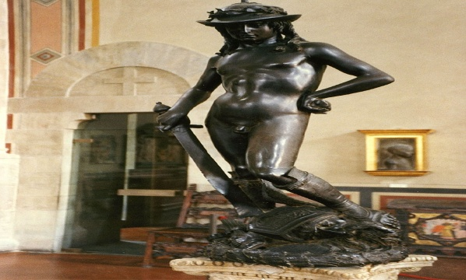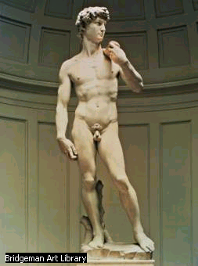

**C:\Program Files\Microsoft Office\MEDIA\CAGCAT10\j0217698.wmfC:\Program Files\Microsoft Office\MEDIA\CAGCAT10\j0217698.wmf**

**C:\Program Files\Microsoft Office\MEDIA\CAGCAT10\j0217698.wmf**