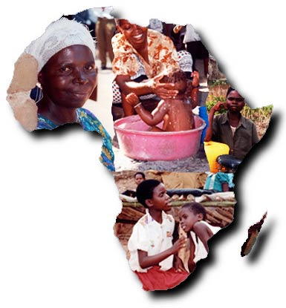
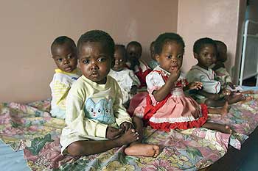
There are an estimated 27 million people living with AIDS or HIV in sub-Saharan Africa today. Since the beginning of this epidemic there has been over 14 million children who have lost one or both of their parents to this disease. Additionally, over 25 million people in sub-Saharan African alone, have died as the result of AIDS. AIDS has altered the fabric of society in many sub-Saharan African countries today. While the spreads of the HIV virus is preventable, experts predict that the number of sub-Saharan Africans who die from AIDS will continue to rise in the future. Consequently, the impact that AIDS has in sub-Saharan Africa is expected to increase over the next decade and possible beyound. The social and econmic consequences of AIDS can clearly be seen in Africa today. AIDS has had both econmic and social consequences in sub-Saharan Africa. The AIDS epidemic in sub-Saharan Africa threatens to devastate whole communities, rolling back decades of development progress.
Directions: Carefully read through your assigned website to gather information to response to a blog question that you will be assigned to answer. In addition to answering your blog question you will also be required to respond to at least five blogs posted by one of your classmates. Your answer to your question must be at least 200 words long and your responses to your classmates must be at least 25 words long.

Blog Questions:
- What is HIV and AIDS? Is there a difference between HIV and AIDS?
- How is AIDS spread?
- Where did AIDS come from? When was the earliest known caseof AIDS?
- In what ways can AIDS be treated?
- What Impact has AIDS had in the United States?
- List and describe three other STDs besides AIDS and describe the impact that they have had in Africa.
- Describe the worldwide statistics regarding to AIDS.
- Is there a cure for AIDS? Are there any treatments?
- In what ways have people living with AIDS been discriminated against?
- What are some of the symtoms of having HIV and AIDS?
- Describe HIV and AIDS education. Why is this type of education important?
- What are some of the myths out there about how people can get HIV and AIDS?
- What is sex education? Does it work?
- What impact has Magic Johnson had on attempts to fight AIDS?
- What is the impact of AIDS in Africa?
- Is treatment for HIV and AIDS avaliable for people who live in Africa?
- Explain the impact that AIDS has had on the children of people who have died from AIDS.
- What percentage of AIDS case in the world today are found in sub-Saharan Africa? What are some of the effects that AIDS has had on Africa? What other place around the world have been effected by AIDS?
- What actions should be taken when it comes to AIDS in the future?
- How have religious leaders been able to help fight the spread of AIDS in Africa?

