Geography Name: _________________________________
Geography of Earth
Mr. Blum

- The Earth travels around the sun in an _______________ shaped orbit. (Slide 2)

- Each rotation of the Earth takes about _______________ hours. (Slide 3)

- Why are the days longer in some parts of the year? (Slide 4)

- Why does the temperature change during the seasons? (Slide 5)

- What event takes place on March 21 and September 23? (Slide 6)

- Low latitudes are areas between the Tropic of ___________________ and the Tropic of ________________________. (Slide 8)

- Describe the climate in the High Latitudes or Polar Zones. (Slide 10)

- What four seasons are found in the Mid-latitudes? (Slide 11)

- _______________ and _____________________ can make climates milder, but they also can create storms. (Slide 13)

- Cyclones occur in the _________________ Ocean. (Slide 14).

- Hurricanes produce huge waves called _________________________________. (Slide 15)

- Typhoons are similar to hurricanes, but they take place in the ____________________ Ocean. (Slide 16)

- Why are tornadoes considered to be dangerous storms? (Slide 17)

- List 4 states located in the “Old Tornado Alley.” (Slide 18)

- List 4 states located in the “New Tornado Alley.” (Slide 18)

- Why do you think that so many more states have been added to the “New Tornado Alley?”

- List the top 5 states that tornados have occurred from 1989-2013. (Slide 19)

Directions: Using the map found on Slide 20 to correctly label the following continents and Oceans.

Continents: North America, South America, Europe, Asia, Africa, Australia, Antarctica.

Bodies of Water: Pacific Ocean, Atlantic Ocean, Indian Ocean, Arctic Ocean

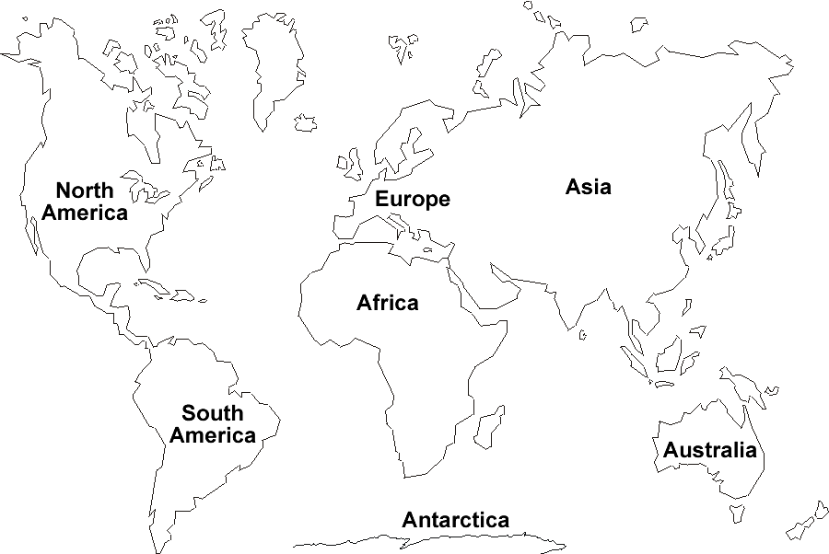

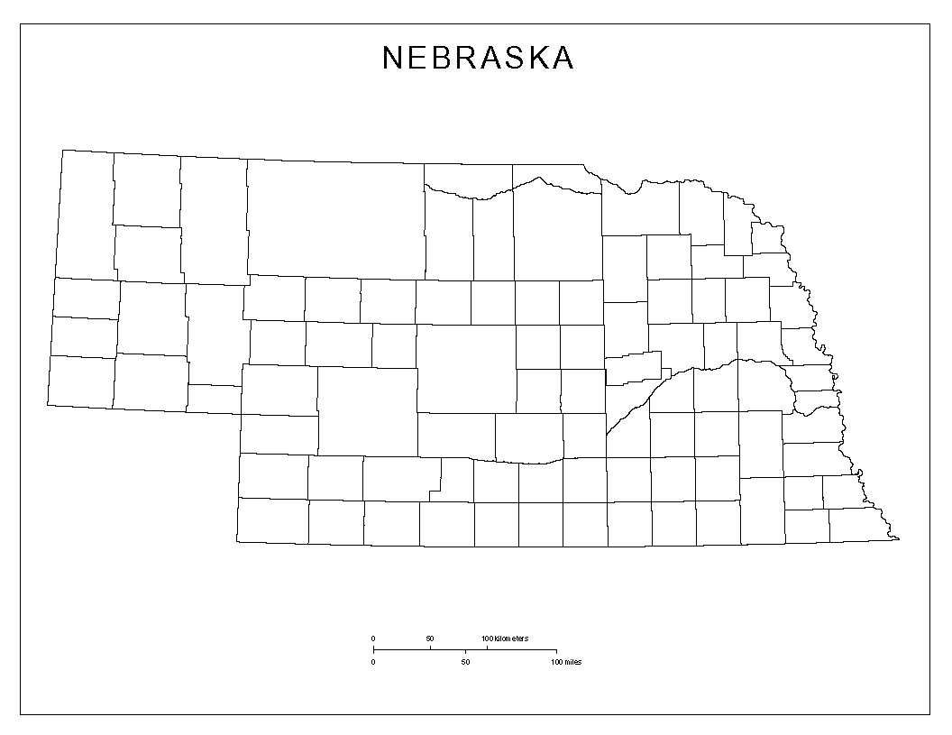
Bonus Question: Using the information found on Slides 21 and 22 correctly label the five most populated and least populated counties in Nebraska.

