Government Name: _________________________________
12 Angry Men
Mr. Blum

Directions: On a separate piece paper answer the following questions as completely as possible by using complete sentences and paragraphs. Answer question number one before viewing this movie and questions 2-7 after watching this video. Your answers to these questions will be typed into the 12 Angry Men blog site on Monday during class.

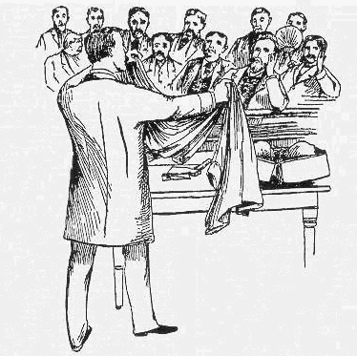
- Should all criminal trials be decided by a unanimous vote by the jury? Some states (Oregon and Louisiana) only require a supreme majority vote of 10 to 2 to convict somebody. Should the vote have to be unanimous or should somebody be convicted to prison or death by a majority vote of something like 7 to 5?

- In your opinion, what is the value of watching the movie 12 Angry Men? Did this movie teach you anything about trial by jury?

- The defendant in this case was a kid who is approximately your age. Are the men represented in this jury really your peers? Explain and defend your answer.

- Would have the accused young man in this case have been better off if his case was decided by a judge? Why or why not? Make sure that you explain and defend your answer.

- If you were the person on trial. Which two members of the jury would you want to have eliminated from this jury? Explain and defend your answer.

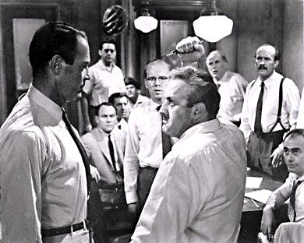
- In your opinion, who would you rank as the two best members of the jury in this case? Why were these people the best members of the jury in your opinion? Explain and defend your answer.

- After watching the movie 12 Angry Men has your answer to question number one changed? Why or why not?

