Facebook and our Founding Fathers
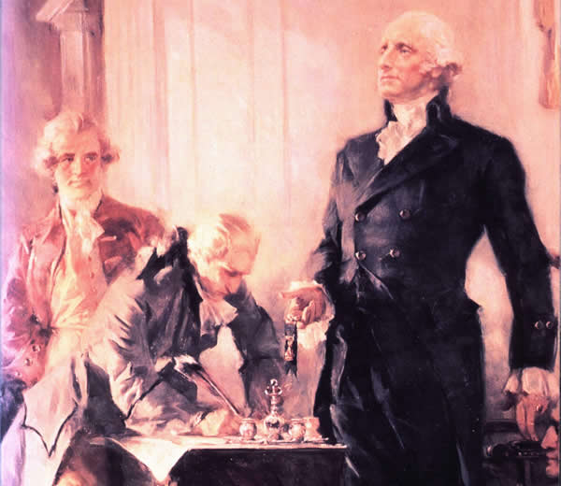
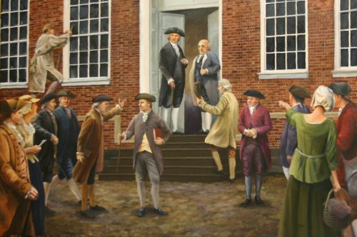
The Constitution created by the fifty-five members of the Constitutional Convention in 1787 is the oldest written constitution that is still in effect in the world today. Our Constitution has shaped the development of the United States over the past two centuries, and it will inevitability continue to shape the development of our country in the future. Nonetheless, the writing of the Constitution did not happen overnight and it certainly did not happen without its share of major arguments. In this assignment we will take a closer look at the individuals responsible for writing the Constitution by creating a facebook wall.
As you are completing this assignment it is important to remember that the framers of the Constitution did not share a collective brain. These men came from a variety of backgrounds, and they did not always agree with each other. If you are looking to find the original intent of the framers of the Constitution, it is important to consider the various beliefs that each of these men held individually. It is also important to remember that the strength of the Constitution was largely a byproduct of the intense debate between these men.
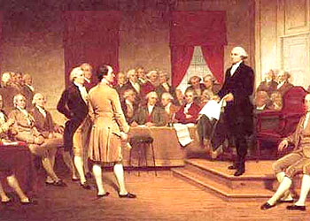
- Directions: Each student will create a facebook wall page for a member of the Constitutional Convention. Your wall must include a picture of your respective person and pictures of six people who might have friended your person. Additionally, at least four of your person’s “friends” must post comments on the wall that they might have said during this time period. Your person must also respond to at least two of the comments made by their friends.
- Feel free to be as creative as possible with this assignment. Trust me you know a lot more about facebook than I do. So be creative and have fun!
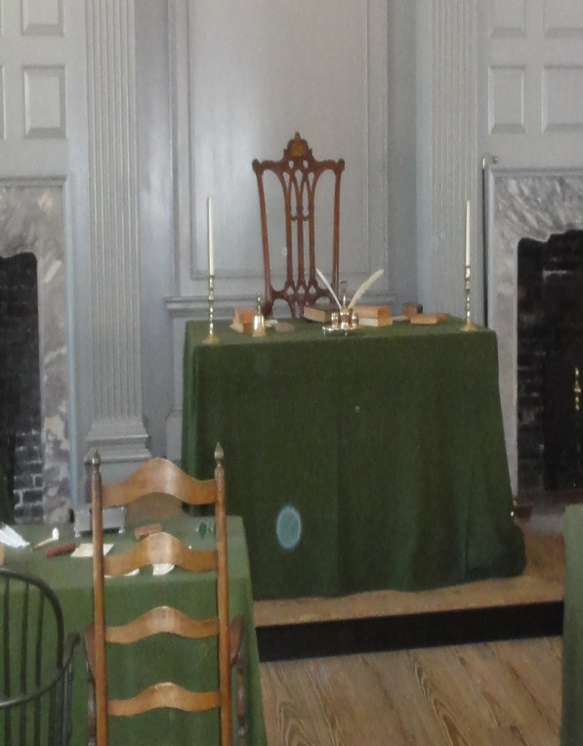
- To find information about your person you should use the following websites for your research:
  - National Constitution Center: http://constitutioncenter.org/ncc_edu_Founders.aspx
  - National Archives: http://www.archives.gov/exhibits/charters/constitution_founding_fathers.html
  - Wikipedia: http://en.wikipedia.org/wiki/Main_Page

