facebook | Home Profile Friends Inbox (1) |  |  |  |  |  |  |  | Settings | Log out
 |  |  |  |  |  |  |  |  | 5 minutes ago
 |  |  | Wall |  | Info | Photos | +
 |  |  |  | What’s on your mind?
George Washington: Just chillin’ in Philly. I was recently elected as the President of a convention to revise the Articles of Confederation.
Alexander Hamilton: Congrats on the big election George! You have lead us well in war and now I anticipate that you will also lead us well in peace. Hey, let’s not just revise these Articles let’s start anew so we can make a stronger central government.
George Washington: Alex good to hear from you! Hey, let’s just take it one day at a time and see what comes out of this convention.
James Madison: George, I like what you’ve done with the teeth dawg. You really are the “Indispensable Man.” I have some big plans for this convention and really believe that we need to make some big changes to save this country.
Martha Washington: Hey baby! You couldn’t have picked out a more handsome looking picture. I am really enjoying the social life here in Philly but I am looking forward to getting back to Virginia.
George Washington: All of my love Martha. I am really looking forward to getting back to Virginia, but I really feel that my country needs me right now.
Marie-Joseph Paul Yves Roch Gilbert du Motier, Marquis de La Fayette: George, all is good here in France. America has the right man leading them through these difficult times. While things are good in France at the moment, I would like to see equality for all French citizens.
Joseph Plumb Martin: General it has been too long since I last spoke to you. Best of luck in Philly! I know that our young country is in good hands. Please don’t forget about the common soldiers. Don’t forget without the sacrifices of common soldiers we would still call ourselves British subjects!

George Washington
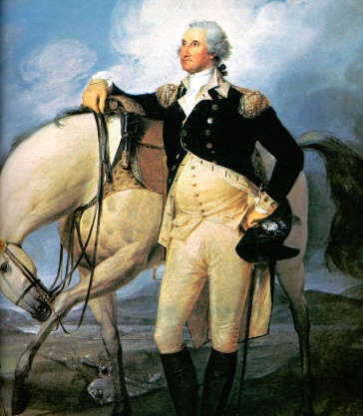
Information
Relationship Status: Married to Martha
Current City: Mount Vernon, Virginia
Birthday: February 22, 1732
Friends

