**Chapter 17: Renaissance and Reformation**

1. Renaissance

* 1300-1600
* Started in Italy
* **Renaissance** –
* Marks the revival of learning, art, and the importance of the individual

**Main Goal of Renaissance**

* Wanted to bring back to life the culture of the Greeks and Romans

1. Rise of Humanism

* **Humanism** –
* Human existence is not just a painful preparation for an afterlife, but had interest and value in itself
* Directly challenged the authority of the Church
* Did not look to the church to answer all of life’s question

**Worldly Pleasure**

* Humanist suggested that people could enjoy life without offending God
* Renaissance was based on a spirit of secularism
* **Secular** –
* Humans have more to offer then blind acceptance of Church doctrines

1. Renaissance Changes Literature

* **Petrarch –**
* Wanted to copy the style and form of ancient Latin

**Niccolo Machiavelli**

* Author of *The Prince* (1513)
* Guide to how a prince should effectively rule his empire
* Was not concerned about what was morally right, but what was politically effective
* Ok for a leader to lie to his people

1. Renaissance Revolutionizes Art

* Renaissance artist started to use realistic art styles base on 3-D perspective
* Rich merchants and the Church began to spend large amounts of money on works of art

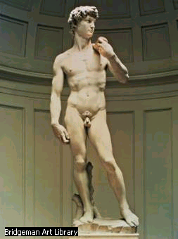

* **Artist** –

**j0217698**

* **Name** -

C:\Program Files\Microsoft Office\MEDIA\CAGCAT10\j0217698.wmf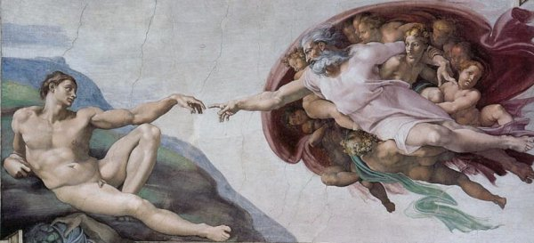

* **Artist** –
* **Name** –

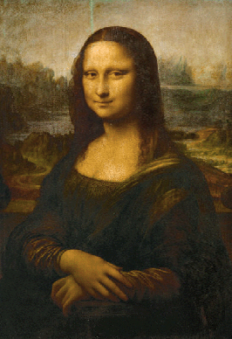

* **Artist** –
* **Name** –

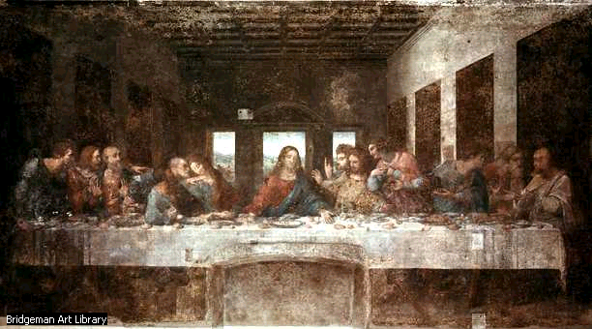

* **Artist –**
* **Name –**

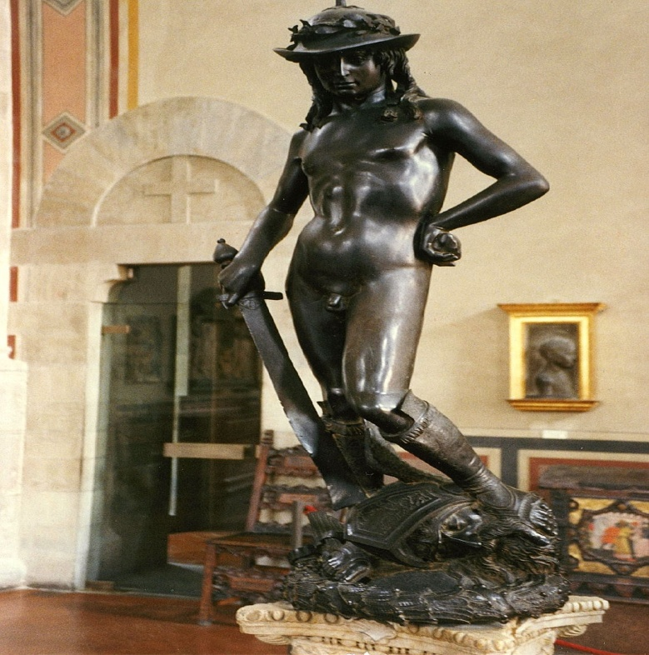

* **Artist –**

C:\Program Files\Microsoft Office\MEDIA\CAGCAT10\j0217698.wmf

* **Name –**

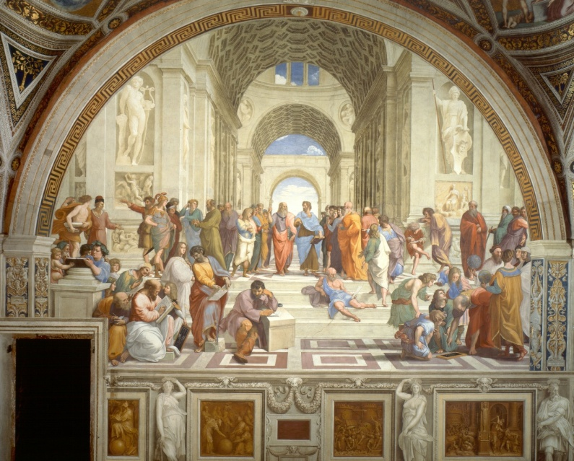

* **Artist** –
* **Name** –